SIMATS ENGINEERING (SAVEETHA SCHOOL OF ENGINEERING)
Department of Computer Science and Engineering

ASSESSMENT TOOL 2 – Industry Problem Solving Task
Course Code: | CSA06 | Course Title: | Design and Analysis of Algorithms
CO Assessed: | CO4: Articulation (BL4, BL5) | Assessment: | Assessment Tool 2 – Industry Problem Solving  Task
Weightage: | 20% of CIA | Total Marks: | 100
CO4 Statement: | Solve optimization problems using dynamic programming and greedy strategies.
Student Name: | Naveen Kumar S | Reg. No.: | 192421030
Section / Batch: | B Tech IT | Date: | 21.08.2026

Criteria | Weightage | Level 4 – Exemplary | Level 3 –  Proficien  t | Level 2 –  Developing | Level 1 –  Beginnin  g

Instructions

to

Students

•

Answer

the

following

question.

Total

Marks:

100.

•

Carefully

analyze

the

given

questions.

•

Explain

in

detail

with

sample

code

if

needed.

•

Clearly

identify

all

key

issues.

•

Provide

a

thorough

analysis

with

validated

results

and

performance

evaluation.

Question Type | Focus Area | Questions
Industry Problem  Solving Task | Focus on Solving optimization problems using dynamic programming and greedy strategies | Q1

SECTION

A

–

Industry

Problem

Solving

Task

Code

of

Conduc
t

I

Naveen

Kumar

S

-

192421030

(
Name

/

Reg

No)

certify

that

this

submission

is

my

original

work

and

that

I

have

adh
ered

to

the

guidelines

specified

for

this

assessment.

I

understand

that

any

violation

of

academic

integrity

rules

will

result

in

disciplinary

action.

Signature

of

the

Student:

Naveen

Kumar

S

RUBRICS FOR CALCULATION

Industry Problem Solving Task
Understanding of Industry Problem | 20% | Comprehensive understanding of real-world  problem and constraints | Good understanding  with minor gaps  in  requirements | Basic understanding; some  requirements unclear | Poor understanding; misinterprets problem context
Application of  Engineering  Concepts | 25% | Applies advanced and relevant concepts  effectively to solve the problem | Applies appropriate  concepts with  minor errors | Limited application of concepts | Incorrect or no application of concepts
Solution Design | 25% | Innovative, practical, and  feasible solution aligned with industry standards | Logical and feasible solution with minor gaps | Basic solution with limited  feasibility | Unclear or impractical  solution
Use of Tools | 15% | Effective use of modern tools,  technologies, and real data | Appropriate use of tools with correct  implementation | Limited or inconsistent use of tools | Minimal or incorrect use of tools
Analysis | 10% | Thorough analysis with validated results and  performance  evaluation | Good analysis with reasonable validation | Basic analysis with limited  validation | Poor or no analysis
Professionalism | 5% | Highly professional,  well-documented, and clearly presented work | Good documentation and presentation | Basic documentation with some gaps | Poor documentation and presentation

Marks Evaluation:
Criteria | Wt. | Level 4 –  Exemplary | Level 3 –  Proficien  t | Level 2 –  Developing | Level 1 –  Beginning
Understanding of Industry Problem | 20%
Application of Engineering Concepts | 25%
Solution Design | 25%
Use of Tools | 15%
Analysis | 10%
Professionalism | 5%
Total Marks (100):

Faculty In-charge | Course Coordinator | Head of Department
Name: | Name: | Name:
Signature: _______________ | Signature: _______________ | Signature: _______________
Date: ___________________ | Date: ___________________ | Date: ___________________

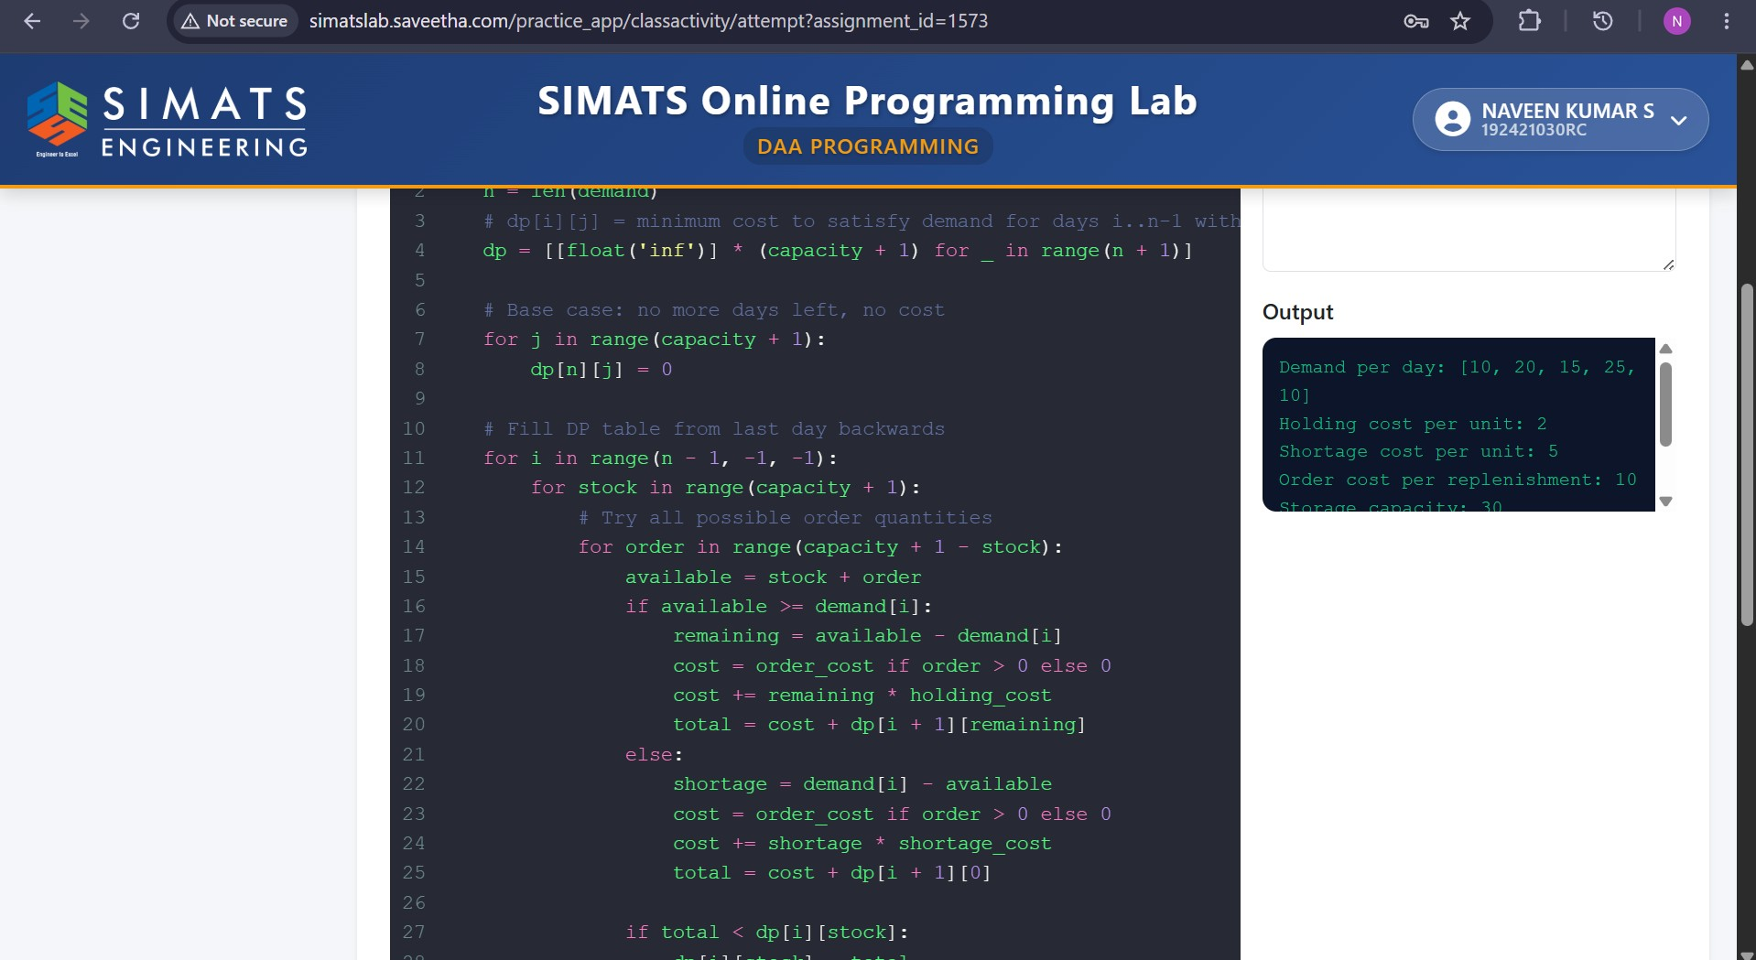

This problem is an Inventory Replenishment Optimization using Dynamic Programming (DP). The goal is to decide how much inventory to order in each period so that the total holding, ordering, and shortage cost is minimized.
1. Problem Formulation
Suppose a retail chain plans inventory for T periods.
For each period t:
- I_t = inventory available at the beginning of period t
- Q_t = quantity ordered in period t
- D_t = demand in period t
- H = holding cost per unit
- S = shortage cost per unit
- C = ordering cost per unit
- M = maximum storage capacity
Inventory after satisfying demand is:
If demand is greater than available inventory, a shortage occurs.

2. Dynamic Programming State
The DP state can be defined as:
where:
- t = current time period
- I = inventory level at the beginning of that period
DP(t,I) represents:
Minimum total cost from period t to the end when the current inventory is I.

3. Cost Function
For an order quantity Q, inventory before demand is:
After demand:
If I' ≥ 0, we have leftover inventory and therefore a holding cost:
If I' < 0, there is a shortage:
The total cost for the decision is therefore:

4. Recurrence Relation
The main DP recurrence is:
This means:
For every possible order quantity Q, calculate the current cost plus the optimal future cost, and choose the order quantity that gives the minimum total cost.
Base case
After the final period:
if no terminal inventory penalty is considered.

5. Algorithm
Algorithm: Inventory Replenishment using Dynamic Programming

Input:
T = number of periods
Initial inventory I0
Demand D[1...T]
Holding cost H
Shortage cost S
Ordering cost C
Maximum storage capacity M

Create DP table DP[t][I]

Set:
DP[T+1][I] = 0 for all possible inventory levels

For t = T down to 1:

For every possible inventory level I:

DP[t][I] = infinity

For every feasible order quantity Q:

Available = I + Q

Remaining = Available - D[t]

HoldingCost = H × max(Remaining, 0)

ShortageCost = S × max(-Remaining, 0)

OrderingCost = C × Q

TotalCost =
OrderingCost
+ HoldingCost
+ ShortageCost
+ DP[t+1][Remaining]

If TotalCost < DP[t][I]:

DP[t][I] = TotalCost
Store Q as the optimal decision

Output:
Optimal order quantity for every period
Minimum total cost
Inventory levels
Total holding cost
Total shortage cost
Total ordering cost

6. Simple Example
Suppose:
- Initial inventory = 10 units
- Demand = 20 units
- Storage capacity = 50 units
- Holding cost = ₹2/unit
- Shortage cost = ₹10/unit
- Ordering cost = ₹1/unit
Consider ordering Q = 15.
Available inventory:
After demand:
So:
- Remaining inventory = 5
- Shortage = 0
Cost:
Therefore:
DP compares this with all other feasible order quantities and selects the one leading to the minimum overall cost, including future periods.

7. Important Constraints
1. Demand variability
Demand may change from period to period.
For example:
A stochastic DP can assign probabilities to different demand values.
The expected-cost recurrence becomes:
This is more realistic for retail because demand is uncertain.

2. Storage limit
The inventory cannot exceed warehouse capacity:
Therefore, only order quantities satisfying this condition are considered.

3. Lead time
If an order takes L periods to arrive, the order cannot immediately satisfy current demand.
For example:
means an order placed in period 1 becomes available in period 3.
In a more advanced DP model, the state includes pipeline inventory:
This allows DP to account for orders that have been placed but have not yet arrived.

8. Why Dynamic Programming Works
At every period, there are multiple possible decisions:
Order 0
/
Current → Order 10
\
Order 20
\
Future periods
DP evaluates these possible decisions and remembers the best future cost for each inventory state.
This avoids repeatedly solving the same subproblem.
The principle used is:
Optimal substructure: The optimal replenishment plan from the current state contains optimal solutions to the remaining subproblems.

9. Computational Complexity
Let:
- T = number of periods
- M = maximum inventory level
- Q = maximum possible order quantity
- D = number of possible demand values
For a simple deterministic model:
time complexity.
Space complexity:
If only the previous period's DP values are needed, space can be reduced to:
For stochastic demand with D possible demand values:
This can become expensive when there are many products, long planning horizons, or many possible demand states.

10. Implementation in Supply Chain Systems
In a real retail system, the DP algorithm can receive:
Input
Historical sales
↓
Demand forecast
↓
Current inventory
↓
Warehouse capacity
↓
Supplier lead time
↓
Cost information
↓
Dynamic Programming
↓
Optimal replenishment schedule
The resulting schedule tells the retailer:
- When to order
- How much to order
- Expected inventory level
- Expected shortage
- Expected total cost

11. Efficiency and Scalability
Advantages
- Produces an optimal solution for the modeled problem.
- Handles multiple periods.
- Can incorporate holding and shortage costs.
- Can incorporate capacity constraints.
- Can be extended to uncertain demand and lead times.
Limitations
- Computational cost increases with the number of inventory states.
- Multiple products make the state space very large.
- Demand uncertainty increases computation.
- Long lead times require more state information.
For very large supply chains, practical systems may use:
- Approximate Dynamic Programming
- Rolling-horizon optimization
- Linear/Integer Programming
- Reinforcement Learning
- Forecasting + optimization hybrids

12. Performance Interpretation
The algorithm should ultimately be evaluated using business measures such as:
Total cost
Inventory reduction
Service level
A good solution should reduce inventory and holding costs without causing excessive shortages.
For example:
Strategy | Holding Cost | Shortage Cost | Total Cost
Existing policy | ₹50,000 | ₹20,000 | ₹70,000
DP policy | ₹35,000 | ₹10,000 | ₹45,000
Cost saving:
Percentage saving:
So the DP strategy would provide both lower inventory-related costs and better inventory optimization.
Final conclusion
Dynamic Programming models inventory replenishment as a sequence of decisions. For each period, it considers the current inventory, possible order quantities, demand, holding cost, shortage cost, storage capacity, and future costs. The recurrence chooses the order quantity that minimizes total cost.
The major advantage is optimal decision-making, while the major disadvantage is increasing computational complexity as the number of products, inventory states, demand possibilities, and planning periods grows. In real supply-chain systems, DP is therefore most practical when combined with forecasting, rolling horizons, and state-space reduction.

